 | Department of Electronics and Computer Engineering

Student Information
Name:- Soham Mandar Joshi
Roll No:- 24204C0021
Class:- TE4K
Division:- C
Batch:- 1
Subject Name:-
Subject Code:-
Practical No:-
Subject Teacher:-
Scheme:- K

ASSINGMENT 1
Q1.Develop a Python program to accept student details such as name and marks of subjects. Calculate total marks, average, and grade using conditional statements. Use proper indentation and comments.
SCRIPT:-
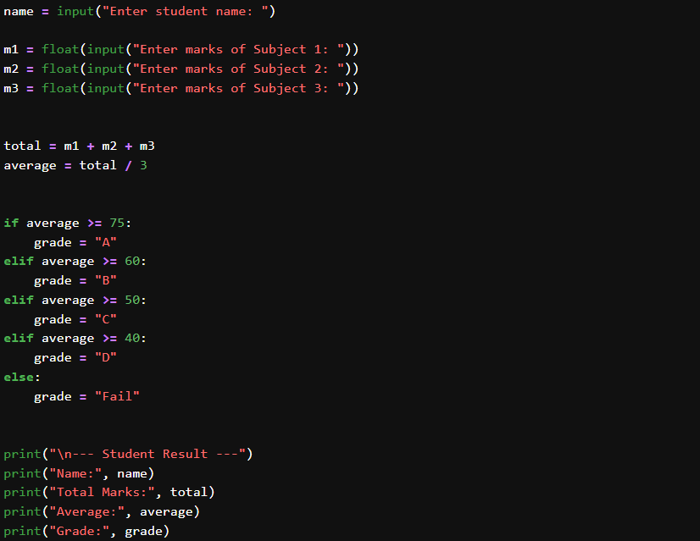
Output:-
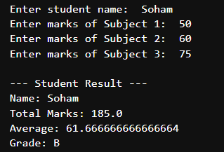

Q2. Write a Python program to store and display college details such as college name, department name, number of students and faculty using variables, data types, and formatted output.
Script:-
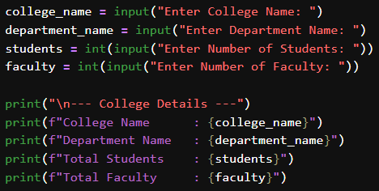

Output:-
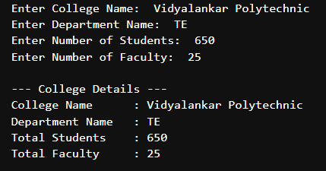

Q3. Develop a menu-driven Python program to calculate total cost of electronic tools using arithmetic operators and conditional statements.

Script:-
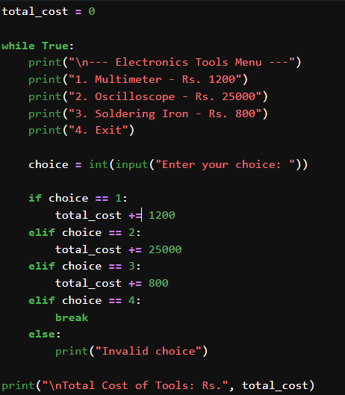
Output:-
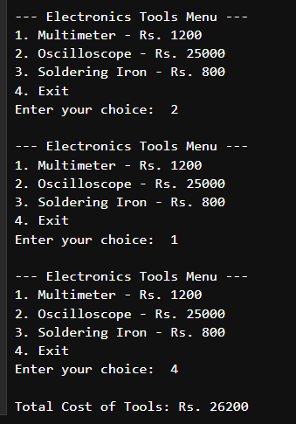
Q4.Create a Python program that accepts document name and document type and classifies the document category using if-else or else-if ladder.
Script:-
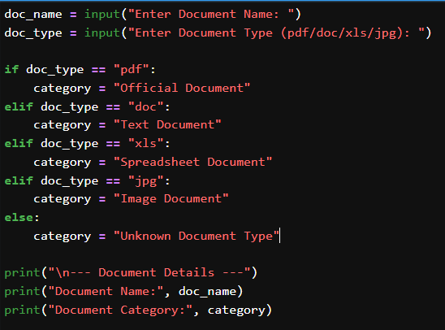
Output:-
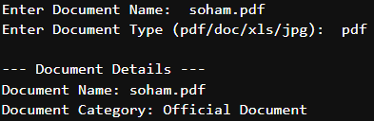

Q5. Develop a menu-driven calculator that performs arithmetic operations using loops and decision-making statements.
Script:-
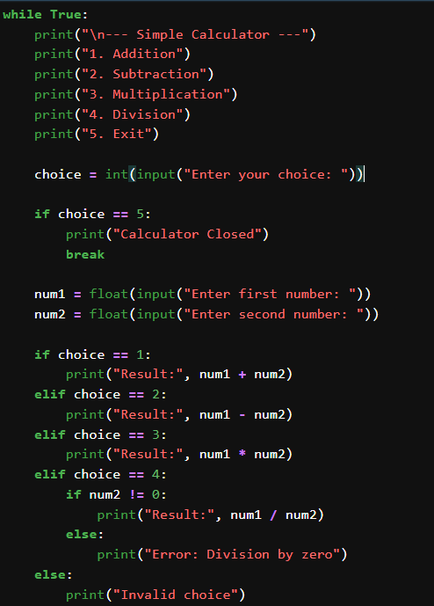

Output:-
